Prevalence of Malocclusion and Orthodontic Treatment Needs among Down Syndrome Sudanese Individuals

Abstract
Objective: To determine the prevalence of malocclusion and orthodontic treatment needs in Sudanese’s Down syndrome individuals in Khartoum area.
Materials and Methods: A total of 75 (37 males and 38 females) Down syndrome individuals age ranging from 6-28 years of age, were clinically examined after obtaining their guardian’s consent. Malocclusion was determined based on Angle and Incisor classification of malocclusion. The data were analysed and presented in tables using the Statistic Package for social sciences (SPSS) program version17 descriptive statistic, Frequency distribution tables and graph were utilized to perform the results.

Results: Angle Class III malocclusion (58.7%) and Incisor III malocclusion (53.3%) represents the most prevalent types of malocclusions. Angle class III malocclusion was more frequent among females (60.5%) than males (56.8%).The majority of individuals with Down syndrome are in great need for orthodontic treatment (85.3%).
Conclusion: The prevalence of malocclusion and orthodontic treatment need among Sudanese Down syndrome individuals was high. Angle and Incisor class III malocclusions represent the commonest trait of malocclusion and reported more frequency in females than males. Orthodontic treatment for Down syndrome individual should be multidisciplinary in order to conservative superior treatment pattern.
Key word: Down syndrome, Class III malocclusion, Orthodontic treatment

Introduction
Down syndrome (DS) is a genetic condition caused by the presence of an extra chromosome 21, or sometimes caused by the duplication of small regions of the chromosome. This condition affects 1 in 800-1100 births. Down syndrome is a major cause of mental retardation and congenital heart diseases. It also causes distinct facial and physical features. It is associated with congenital anomalies of the gastrointestinal tract, an increased risk of leukaemia, immune system defects, and an Alzheimer-like dementia.^{[1]}

Down syndrome was first described in 1866 by Dr John L. H. Down. Individuals with Down syndrome have many dental conditions suited to be considered for orthodontic treatment. ^{[2]}
In individuals with Down syndrome, there are some unique characteristics, Systemic anomalies which include; arterial sepals defects, patent ductus arteriosus, lymphopenia, eosinopenia, Leukemia, increased laxity of ligaments, underdeveloped mid face, delayed motor function, Dementia, Natural spontaneity, genuine warmth, gentleness, patience, tolerance, ventricular septal defect, and a few patients present with anxiety and stubbornness. Oral anomalies include; reduction in length, height, and depth of the palate, hypotonic tongue, fissured tongue, scalloped tongue, and macroglossia.^{[3]}
Dental anomalies include; delayed eruption of primary teeth instead of around six month to a year or more, delayed eruption of permanent teeth, reduction in size of teeth, presence of spacing due to small sized teeth, missing teeth, malpositioned teeth, microdontia hypolplasia partial anodontia, supernumerary teeth, hypodontia, taurodontism, crown variants, difference in the order of teeth eruption, deficient growth in the upper arch and Bruxism.^{[3-4]}

Occlusion is defined as the manner in which the upper and lower teeth intercuspate between each other in all mandibular positions and movements. It is a result of neuromuscular control of the components of the mastication systems namely: teeth, periodontal structures, maxilla, mandible, temporomandibular joints and their associated muscles and ligaments.^{[5]}

Malocclusion term was first invented by Guilford, it occurs in the majority of the population. It is neither a normal or unhealthy condition. It is difficult to prove a single major cause of malocclusion as it develops slowly as a child grows and the development of occlusion is very vulnerable to many influences.⁶Malocclusion is defined as an anomaly which causes disfigurement or which impedes function, and requires treatment, if the disfigurement or functional defect was likely to be an obstacle to the patient’s physical or emotional well-being.” Malocclusion might be associated with one or more of the following: Malalignment of individual teeth in each arch, mal-relationship of the dental arches relative to the normal occlusion (in antero-posterior, vertical or transverse planes).^{[5]}

In the 21st century, researches proposed two broad set of theories to explain causes of occlusal variation; genetics and the role of environment.^{[6,7,8]} Proffit^{[6]} and McDonald^{[8]} had suggested that crowding and mal-alignment were due primarily to inherited tendencies that determine facial proportions and soft tissue contour, as well as teeth and jaw size. Mild and moderate degree of mal-alignment might be present even in the absence of habits or environmental factors, however extremely severe crowding probably has a genetic component as well as an environmental component.

Different methods of malocclusion classification had been recognized may be applied for different purposes. The requirements for clinical categorization differ from those of epidemiology.^{[9]}Several types of indices had been developed to describe the malocclusion; Epidemiological data collection (which measure the occlusal traits),^{[10]} Occlusal classification (Angle’s classification and incisors classification), ^{[11,12]} Priority treatment need - dental health need,^{[13]} (IOTN) Index of Orthodontic Treatment need,^{[14]} Treatment success (which compares pre and post orthodontic treatment records and register the quality of the outcome) ^{[15]} and the Dental arch relationships (Which categorizes dental arch relationships in children with unilateral complete cleft lip and palate).^{[16]}The need of treatment depends on the aesthetics, and if treatment is detrimental to heath of the teeth and the supporting structures.^{[17]}

According to a statistical study done by US Census Bureau to determine the incidence of Down syndrome around the world, in Sudan, out of 39148162 individual examined, 48935 were found to have down syndrome.^{[18]} In spite of this high number, to our knowledge, no published studies regarding the malocclusion and need for orthodontic treatment among individuals with Down syndrome was available. Therefore this study was designed to determine the prevalence of malocclusion and orthodontic treatment need in a sample of Sudanese’s Down syndrome individuals in Khartoum area.

Materials and Method
An ethical clearance was obtained first from the research committee, faculty of dentistry, University of Medical Science and Technology, as well as the authorities of the special needs centers to conduct the study. The total number of the special needs centers in Khartoum area was 53 as obtained from the directorate of special needs in Ministry of Education- Khartoum State. A preliminary visit to the centers was carried out to explain the purpose of the study, and to obtain permission from the head of the centers and parents to carry on this study, and then a cross-sectional descriptive community based study was carried out on Down syndrome individuals.
All of the headmasters of the centers were contacted to identify the current available numbers of Down syndrome individuals. Since the total number of children with Down syndrome attending special needs centers in Khartoum state was small, it was decided to include all individuals with Down syndrome in this study. A consent letter was sent to the parents of the individuals with Down syndrome through the centers authorities to be sign for agreement to carry clinical examination for their children.
All Down syndrome individuals whose parents signed the consent paper and fulfilled the inclusion criteria; diagnosed with Down syndrome at any level with intelligence percentage, good cooperation during clinical assessment were included in this study and the one who received or were receiving orthodontic treatment were excluded. The clinical examination was carried out by the main researcher in the teacher’s office sitting in an ordinary chair in front of the investigator using natural day light. Sterilized examination sets were used for each individual, and data sheet was filled for each one, the vertical overbite were measure by steel ruler directly in the oral cavity. Individuals who had dental problems, malocclusion, or bad oral hygiene were referred to the dental clinic at the University of Medical Science and Technology for the required treatment.
The following criteria were used to assess the type of malocclusion and treatment need. ^{[10-14]}
The occlusion was classified into normal occlusion or malocclusion using the first permanent molar as described by Angle.
Class I: Normal relationship of the first permanent molars mesobuccal cusp of upper first permenant molar occluded in the buccal grove of the lower firt permenant olar, but line of occlusion incorrect malaligned teeth due to rotation or other causes.
Class II: Lower first permanent molar distally positioned relative to upper molar.
Divison 1 proclined upper incisors
Divsion 2 retroclined upper incisors
Class III: Lower first permanent molar mesially positioned relative to upper molar, with or without reversed over jet
Incisors classification of malocclusion
Class I: The lower incisor edges lies below the cingulum plateau of the upper central incisors.
Class II: The lower incisors edges lies posterior to the cingulum plateau of The upper central incisors:
Division 1: Proclined upper incisors and increase over jet.
Division 2: Retroclined upper incisors and decrease over jet.
Class III: The lower incisors edge lies anterior to the cingulum plateau of the upper incisors,
Over jet reduced or reversed.
Deep bite:
Grade 1: 0-2.9 mm the vertical overlapping of the upper and lower right incisors.
Grade 2: 3-4.9mm
Grade 3: 5mm or more overlapping
Frontal open bite:
Grade 1: 0-1-9mm
Grade 2: -2mm and more
Need of treatment: are assessed either there is need of treatment or no need of treatment
Data Processing and Analysis:
Data were collected, summarized, coded and entered to the Statistical Package for Social Sciences (SPSS) program (version 17) in the computer. Descriptive statistics were utilized to contact the results. Frequency distribution tables, graph were used to represent the results.

Results
The total number of Down syndrome individuals attending 53 special need centres in Khartoum area was 104. Three individuals had orthodontic treatment, 14 of which whose parents refused to retain the consent form and five students at holiday with parents and seven individuals we faced difficulty to examine them. Therefore, the number included the present study were 75 Individuals, 37 (49.3%) males, and 38 (50.7%) females their age range was 6-23 years old.
Table 1 and 2 showed that the most prevalent type of malocclusion according to Angle’s classification was class III malocclusion in all age groups, representing in females (60.5%) and in males (56.8%). followed by class II malocclusion.
Table 3 and 4 showed that Incisor class III malocclusion was the highest type (58.1%) among all age groups (54.1%) in males, while in females (52.6%), followed by class II incisors malocclusion.
Figure 1 showed the vertical malocclusion in examined Down syndrome individuals; open bite was found to be (38.7%) followed by edge to edge bite (32.0%) and only (8%) had normal bite.
Figure 2 and 3 showed the distribution of age group and gender according to the need for orthodontic treatment, most individuals (32 males and 32 females) are in need of orthodontic treatment and only 11 out of 75 no treatment was required.

Discussion
This is a cross-sectional study aimed to determine the prevalence of malocclusion and orthodontic treatment need in Down syndrome individuals attending Special needs centers in Khartoum area and compare the results with the previous finding among other populations.
The total numbers of the Down syndrome individuals, at 53 centers of special needs in Khartoum area was found to be 104 individuals with age ranges from 6 to 23 years old. To our knowledge the numbers of Down syndrome individuals in Khartoum state was much more than the one attending special need centres. This fact may be partially attributed to the lack of knowledge about the syndrome itself among the population and the majority of parents prefer the Down syndrome individual to stay at home for security and better health care than outdoors.
Since all Down syndrome individuals in the 53 special needs centers in Khartoum area was planned in consideration of the individual cooperation so, no age range was determined prior to this study, consequently the wide age range of the individuals. Nevertheless, the distribution of individuals for age group (31 individuals 6-11years, 30 individuals 12-17 years, and 14 individuals 18-23 years) concerning gender; males 37 and female 38 which almost identical. The clinical examination was performed directly on the oral cavity by the main investigator according to Angles and incisors classification of malocclusion.
In general, individuals with Down syndrome in the current study appeared to exhibit a high incidence of malocclusion. In addition Class III malocclusion was the most common trait of malocclusion among Sudanese’s Down syndrome individuals and these findings consistent with previous results among different Down syndrome population worldwide.¹⁹⁻²⁴ This results may be partially attributed to an distorted cranial base relationship, reduce arch length relationship an decreased maxillary arch size.^{[20, 25]}
Further, the percentage of Class III malocclusion among normal Sudanese population was very small (3%). ^{[25]} The fact that Class III malocclusion is predominately a feature among Down syndrome population.
Almost two third of the individuals with Down syndrome had either open bite or edge to edge bite, while only (8%) had normal bite so this finding online with the results obtained in previous literature.^{[26,27]}
Differences in the results between Down syndrome and normal individuals in all malocclusion classifications may be due to the known skeletal conditions among Down syndrome individuals, whereas difference in results between Down syndrome individuals in different countries may be partially attributed to the difference in age groups, sample size, gender, geographical area, environmental factors and ethnic background.
The present study revealed that large percentage (85.3%) of individuals with Down syndrome (32 males out of 37 and 32 females out of 38) were in need of orthodontic treatment due to certain types of malocclusion which indicated that treatment is extremely required and obligatory, this results was usual and in harmony with earlier studies documented the frequent relationship between orofacial dysfunction, malocclusion and Down syndrome.^{[22]}
The results of the current study warrants further comprehensive investigation should be voted for different parts in Sudan in order to increase the sample size and be more reprehensive. Then the overall prevalence of Down syndrome individuals, as well as malocclusion and treatment needs will be of great value for orthodontic and health services authorities.

Health service centers should have special attention to the disabilities population, and should establish force educational programs about dental consciousness and oral hygiene information for children, parents and teachers in special needs centers, so those groups of individuals with Down syndrome can have more attention. Mental or physical limitations should not be an obstacle to providing dental services and treatment. Determination of the degree of malocclusion, identification of consequences of no treatment, establishing goals and outcomes of treatment should be a must.

Conclusions
- High prevalence of malocclusion was observed among the sample of Sudanese Down syndrome individuals. Angle class III and incisor class III malocclusions represent the commonest trait and more frequency in females than males.
- Orthodontic treatment for Down syndrome individual should be multidisciplinary in order to conservative superior treatment pattern, both orthodontic, general dentist and parents be obliged to recognize the treatment goals, so appropriate and treatment outcome will be achieved.

References

J R Korenberg, X N Chen, R Schipper, Z Sun, R Gonsky, S Gerwehr, N Carpenter, C Daumer, P Dignan, and C Disteche Down syndrome phenotypes: the consequences of chromosomal imbalance. 1994; 11: 4997-5001.
- David R. Musich, DMD, MS Schaumburg. Orthodontic Intervention & Patients with Down syndrome, The Role of Inclusion, Technology & Leadership, the Angle Orthodontics J, 2006; 1-2.
- Sindoor S. Desai, BDS Down syndrome: A Review of the Literature Oral Surgery, Oral Medicine, Oral Pathology, Oral Radiology, and Endodontics September 1997; 84 3: 279-285.
- Elizabeth S. Pilcher, DMD Department of Prosthodontics College of Dental Medicine Medical University of South Carolin Your Child's Dental Health © Down syndrome News, November 1996;9: 114.
- Ash MM and Ramfjord SP Occlusion, 3rd edn. Philadelphia: W.B. Saunders Co 1982.
- Proffit WR and Fields HW. Contemporary Orthodontics. Chicago: Mosby Year Book, 2000: 1-15
- Corrucini RS. An epidemiological transition in dental occlusion in world population. Am J Orthod Dentofacial Ortho, 1984; 86: 419-426.
- McDonald F and Ireland AJ. Diagnosis of the Orthodontic Patient. New York: Oxford University Press 1998.
- Houston WJB, Stephens CD and Tulley WJ. A Textbook of Orthodontics, Great Britain: Wright, 1992: 1-13.
- Bjork A, Krebs AA and Solow B. A method for epidemiological registration of malocclusion. Ac Odontol Scand, 1964; 22: 27-41.
- Angle EH. Classification of malocclusion. Dental Cosmos, 1899; 4: 248-264.
- Mitchell, L., An Introduction to Orthodontic.USA: New York; 2001.
- Draker HL Handicapping labial lingual deviations. A proposed index for public health purposes. Am J Orthod Dentofacial Orthop. 1960; 46: 295-305.
- Brook PH and Shaw WC. The development of an index of orthodontic treatment priority. Eur J Ortho.1989; 11: 309- 320.
- Richmond S, Shaw WC, O’Brien KD, Buchanan BI, Jones R, Stephens CD, Roberts CT and Andrews M. The development of the PAR index (Peer Assessment Rating): reliability and validity. Eur J Ortho, 1989; 14: 125-139.
- Mars M, Plint DA, Houston WJ, Bergland O and Semb G Goslon Yardstick. A new system of assessing dental arch relationships in children with cleft lip and palate. Cleft Palate Craniofac J. 1987; 4: 314-322.
- BS Phulari. Orthodontics Principals and Practice. 1st edn. 2011: 3-4.
- Right diagnosis.com (homepage on the Internet) US: US Census Bureau population Estimates, US Census Bureau International Data Base; 2004 (Update: 1 February, 2012) available from: http://www.rightdiagnosis.com/d/down_syndrome/stats-country.htm.
- Vittek J, Vinik S, Winik A, Sioris C, Tarangelo AM, Chou M. Analysis of orthodontic anomalies in mentally retarded developmentally disabled (MRDD) persons. Spec Care Dentist.1994; 14: 198-202.
- Shyama M, Al-Mutawa SA, Honkala S. Malocclusion and traumatic injuries in disabled schoolchildren and adolescents in Kuwait. Spec Care Dentist. 2001;21:104-108

- Onyeaso CO. Orthodontic Treatment need of mentally handicapped children in Ibadan, Nigeria, according to the dental aesthetic index. J Dent Child (Chic). 2003; 70 no. 2: 159-163.
- Roa DB, Hedge AM, Munshi AK. Malocclusion and orthodontic treatment need of handicapped individuals in South Canara, India. Int. Dent J. 2003; 53: 13-18.
- Oliveira AC, Paiva SM, Campos MR, Czeresnia D. Factors associated with malocclusions in children and adolescents with Down syndrome. Am J Orthod Dentofacial Orthop. 2008 Apr; 133(4):489.e1-8. Doi: 10.1016/j.ajodo.2007.09.014.
- Basma K. Al Sakarna, BDS, M Dent Sci, JDB Enas Othman, BDS, JDB. Denofacial changes and oral health status in individuals with Down syndrome in Jordan. Pakistan Oral & Dental Journal. 2010; 30(1):159-161.
- Abu Affan A.H, P.J Wisth and O.E. Boe. Malocclusion in 12 years old Sudanese children. Odontostomal Trop, 1990.13(3): 87-93.
- Vigild M. Prevalence of malocclusion in mentally retarded young adults. Community Dent Oral Epidemiology. 1985; 13:183-4.
- Ondarza A, Jara L, Bertonati MI,Blanco R. Tooth malalignment in Chilean children with Down syndrome. Cleft palate Craniofac J. 1995;32:188-193

Table 1: Distribution of Angle’s classification of malocclusion among Down syndrome individual
Angle classification | Age group |  |  | Total
Angle classification | 6 - 11 years | 12 - 17 years | 18 - 23 years | Total
class I | 2 | 6 | 1 | 9
 | (6.5%) | (20.0%) | (7.1%) | 12.0%
class II | 10 | 6 | 6 | 22
 | (32.3%) | (20.0%) | (42.9%) | 29.3%
class III | 19 | 18 | 7 | 44
 | (61.3%) | (60.0%) | (50.0%) | 58.7%
Total | 31 | 30 | 14 | 75
 | 100.0% | 100.0% | 100.0% | 100.0%

Table 2: Distribution of Angle's classification of malocclusion among genders.
Angle's classification | Gender |  | Total
Angle's classification | Male | Female | Total
class 1 | 6 | 3 | 9
 | (16.2%) | (7.9%) | 12.0%
class II | 10 | 12 | 22
 | (27.0%) | (31.6%) | 29.3%
class III | 21 | 23 | 44
 | (56.8%) | (60.5%) | 58.7%
Total | 37 | 38 | 75
 | 100.0% | 100.0% | 100.0%

Table 3: Incisor’s classification in different age groups.
Incisor’s classification | Age |  |  | Total
Incisor’s classification | 6 - 11 years | 12 - 17 years | 18 - 23 years | Total
class I | 2 | 9 | 1 | 12
 | (6.5%) | (30.0%) | (7.1%) | 16.0%
class II | 11 | 6 | 6 | 23
 | (35.5%) | (20.0%) | (42.9%) | 30.7%
class III | 18 | 15 | 7 | 40
 | (58.1%) | (50.0%) | (50.0%) | 53.3%
Total | 31 | 30 | 14 | 75
 | 100.0% | 100.0% | 100.0% | 100.0%

Table 4: Incisor’s classification among Down syndrome individuals.
Incisor’s classification | Gender |  | Total
Incisor’s classification | Male | Female | Total
class I | 7 | 5 | 12
 | (18.9%) | (13.2%) | 16.0%
Class II | 10 | 13 | 23
 | (27.0%) | (34.2%) | 30.7%
class III | 20 | 20 | 40
 | (54.1%) | (52.6%) | 53.3%
Total | 37 | 38 | 75
 | 100.0% | 100.0% | 100.0%

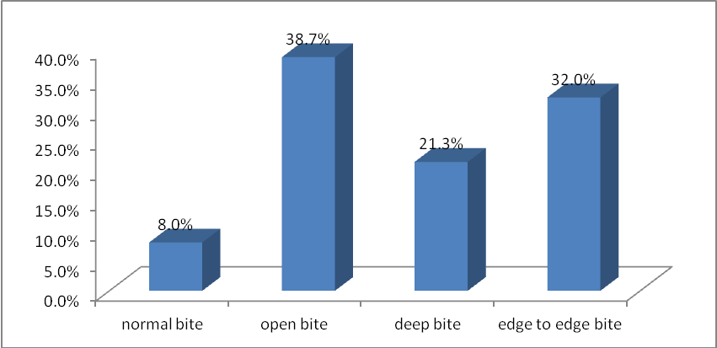
Figure 1: Vertical malocclusion among Down syndrome individuals.

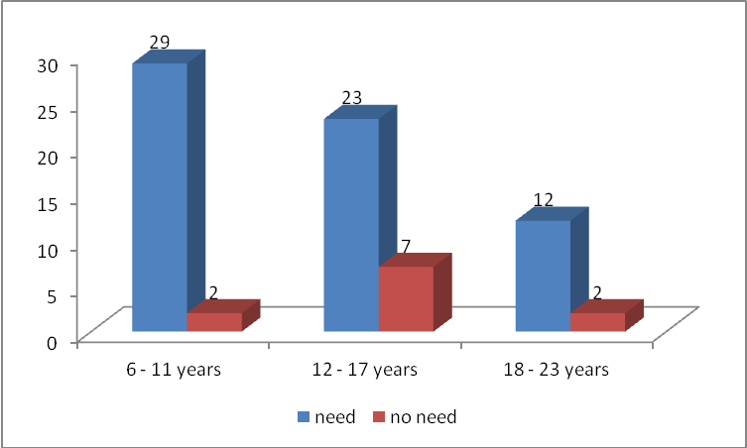
Figure 2: Distribution of orthodontic treatment need in different age group with Down syndrome.

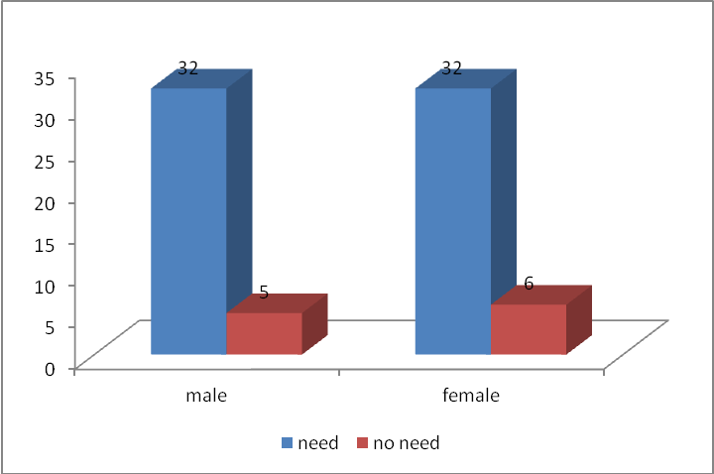
Figure 3: Orthodontic treatment need for Down syndrome individual in both genders.

