COPYRIGHT TRANSFER AND RESPONSIBILITY STATEMENT

All manuscript's copyright ownership of the article "Multidisciplinary esthetic approach for multiple anterior diastema: 36-month clinical performance" is transferred from the author(s) to the BRAZILIAN DENTAL SCIENCE, in the event the work is published. The manuscript has not been published elsewhere and that it has not been submitted simultaneously for publication elsewhere.
We hereby attest the study is original and does not present manipulated data, fraud or plagiarism. We made significant scientific contribution to the study and we are aware of the presented data and in agreement with the final version of the manuscript. We assume complete responsibility for the ethical aspects of the study.

Karin Cristina da Silva MODENA 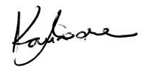
Bella Luna COLOMBINI-ISHIKIRIAMA 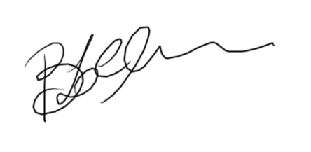
Sérgio Kiyoshi ISHIKIRIAMA 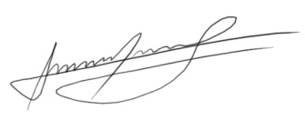
Cassiana Koch SCOTTI 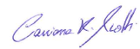
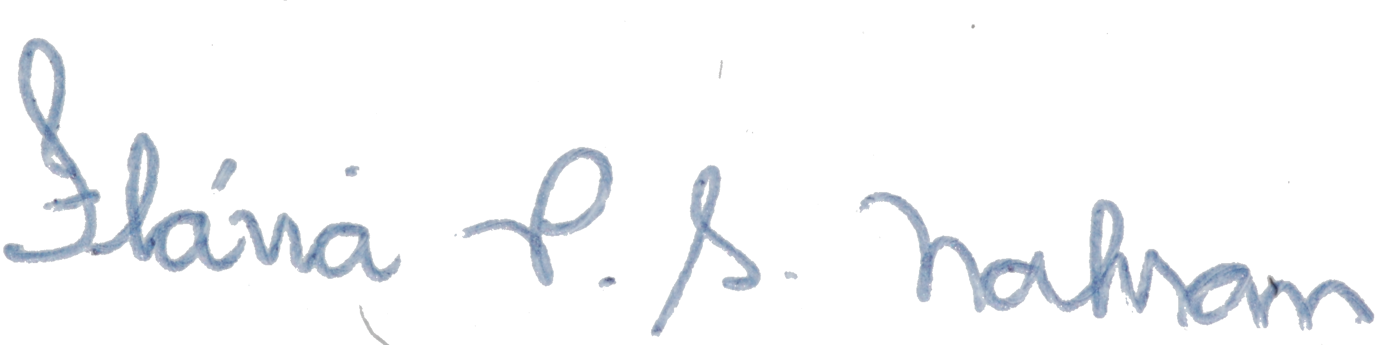
Flavia Pardo Salata NAHSAN

