COVER LETTER

Dear Editor,
We are sending the article “Antimicrobial activity of calcium hydroxide associated with a new vehicle (Triethanolamine)” written for analysis and publication on Brazilian Dental Science.
We affirm that the manuscript represents an original work and it is being submitted only to this Journal for consideration for publication and has not been presented elsewhere. All the authors are responsible by the content of the article.
The authors deny any conflicts of interest related to this study.
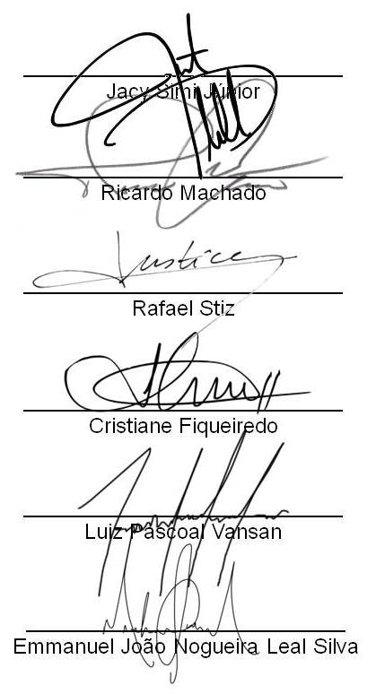

Brazil, 14/10/2015.

