COPYRIGHT TRANSFER AND RESPONSIBILITY STATEMENT

All manuscript's copyright ownership of the article " Avaliação de sinais e sintomas de DTM em Indivíduos em tratamento ortodôntico" is transferred from the authors to the BRAZILIAN DENTAL SCIENCE, in the event the work is published. The manuscript has not been published elsewhere and that it has not been submitted simultaneously for publication elsewhere.
We hereby attest the study is original and does not present manipulated data, fraud or plagiarism. We made significant scientific contribution to the study and we are aware of the presented data and in agreement with the final version of the manuscript. We assume complete responsibility for the ethical aspects of the study.
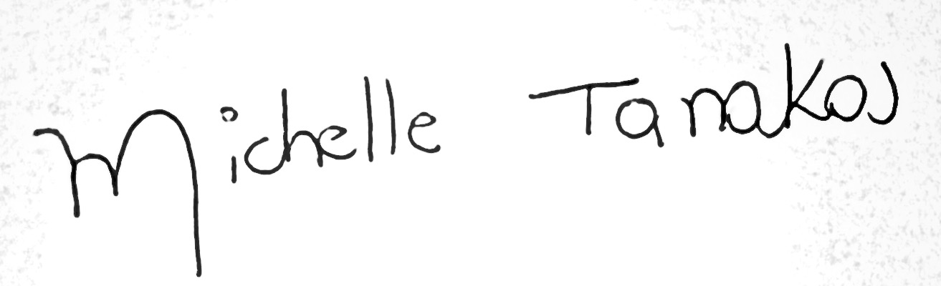
Michelle Mayumi Yokoya Tanaka
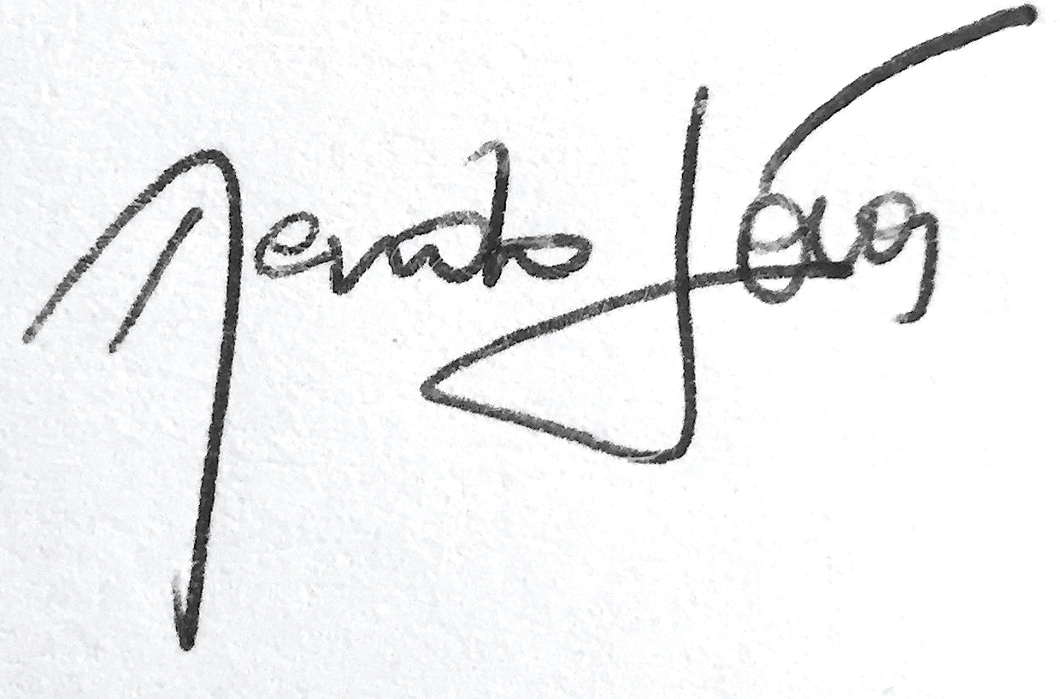
Renato Morales Jóias
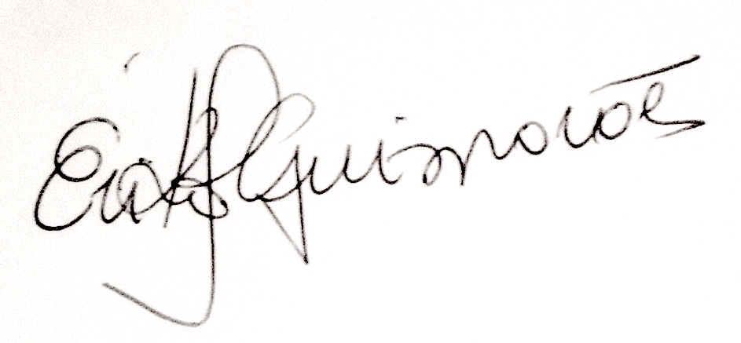
Erika Josgrilberg
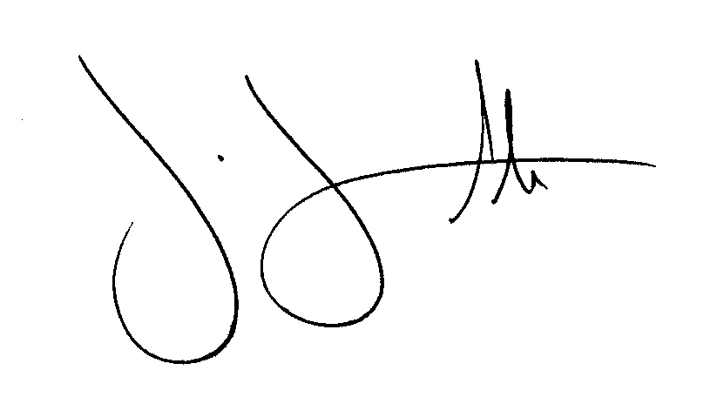
Sigmar de Mello Rode
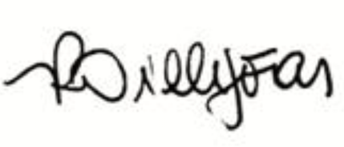
Renata Pilli Jóias

