COPYRIGHT TRANSFER AND RESPONSIBILITY STATEMENT

All manuscript's copyright ownership of the article "EFFECT OF DIFFERENT CONCENTRATIONS OF NANOHYDROXYAPATITE ON TOOTH BLEACHING EFFECTIVENESS AND ENAMEL BOND STRENGTH" is transferred from the author(s) to the BRAZILIAN DENTAL SCIENCE, in the event the work is published. The manuscript has not been published elsewhere and that it has not been submitted simultaneously for publication elsewhere.
We hereby attest the study is original and does not present manipulated data, fraud or plagiarism. We made significant scientific contribution to the study and we are aware of the presented data and in agreement with the final version of the manuscript. We assume complete responsibility for the ethical aspects of the study.

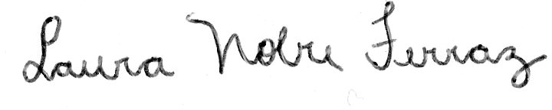
Laura Nobre Ferraz


Waldemir Francisco Vieira Júnior

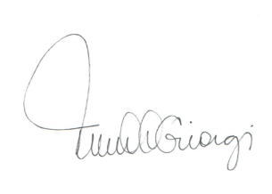
Maria Cecília Caldas Giorgi

Gláucia Maria Bovi Ambrosano


Flávio Henrique Baggio Aguiar

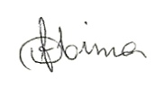
Débora Alves Nunes Leite Lima

