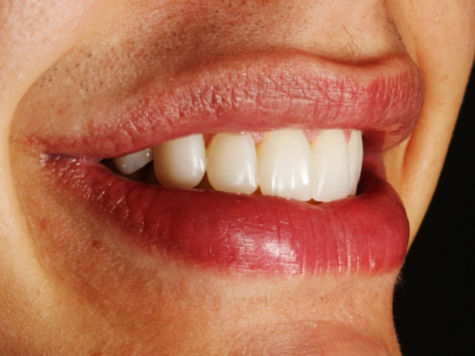 Figure 13 - Side view of the final patient smile