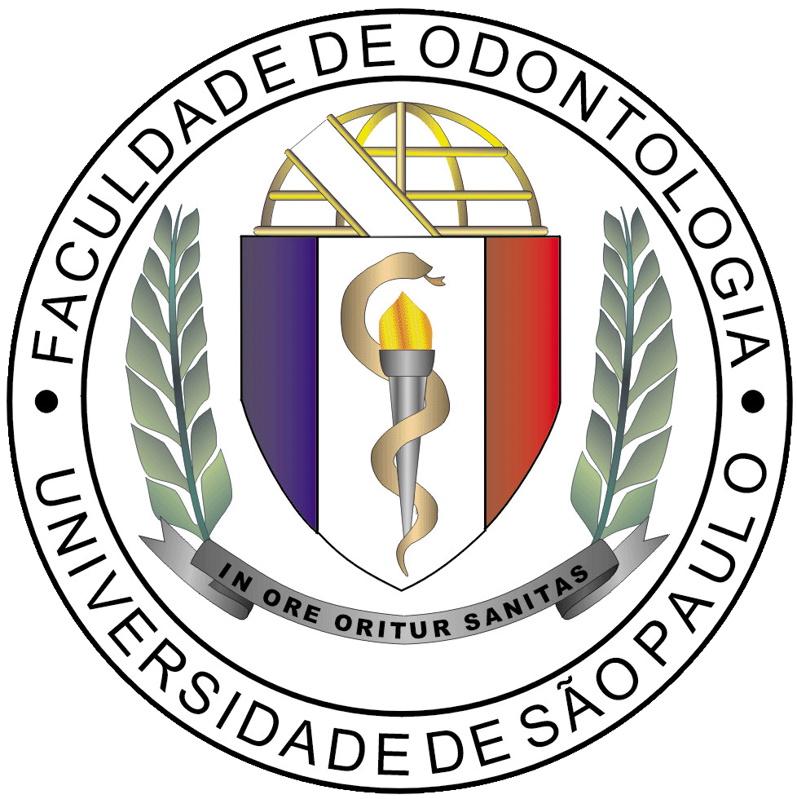
Faculdade de Odontologia da Universidade de São Paulo
Avenida Professor Lineu Prestes, 2227 – Operative Dentistry Department
E- mail: bona@usp.br telefone: +55-11-2648-8012
Cidade Universitária - São Paulo, CEP 05508-900, Brazil

Authors:
Beatriz Togoro Ferreira da Silva
Livia Tosi Trevelin
Fernanda de Sá Teixeira
Maria Cecília Salvadori
Paulo Francisco Cesar
Adriana Bona Matos

Dear Editor Sergio Gonçalves,

We are submitting the manuscript “Non-thermal plasma increase bond strength of zirconia to a resin cement” for your consideration to be published in Brazilian Dental Science.
A durable and stable bond between luting cements and ceramics is fundamental for the long-term performance of esthetic dental restorations. However, the conventional surface treatments of zirconia, such as air abrasion and tribochemical silica coating, creates critical defects on the ceramic surface and also may not result in a better bonding performance. To overcome this problem, it is possible to use non-thermal plasma which can modify the chemical surface of zirconia prior to cementation without damaging its structure. Therefore, we believe that the novelty of this investigation relies on the fact that it is the first study to suggest that plasma surface treatment, as a non-destructive method, to effectively enhance the bond strength of a new formulation of a resin cement (Panavia V5) with Y-TZP surfaces. Based on our conclusions, oxygen plasma should be an alternative strategy for zirconia surface treatment prior luting.
All authors have effectively contributed to this work and are familiar with its contents, that justify their inclusion as authors of this study. The content is original and does not consist of plagiarism or fraud. The work is not under consideration or will be submitted to other journal until a final decision is issued by this journal.

We hope to hear from you at your earliest convenience.

Yours sincerely,

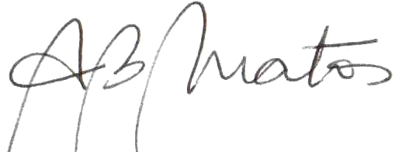
Adriana Bona Matos
Full Professor at FOUSP

