COPYRIGHT TRANSFER AND RESPONSIBILITY STATEMENT
All manuscript's copyright ownership of the article “Restorative strategies for weakened roots: Systematic review and Meta-analysis of in vitro studies” is transferred from the author(s) to the BRAZILIAN DENTAL SCIENCE, in the event the work is published. The manuscript has not been published elsewhere and that it has not been submitted simultaneously for publication elsewhere.
We hereby attest the study is original and does not present manipulated data, fraud or plagiarism. We made significant scientific contribution to the study and we are aware of the presented data and in agreement with the final version of the manuscript. We assume complete responsibility for the ethical aspects of the study.
Name: Gislene Côrrea
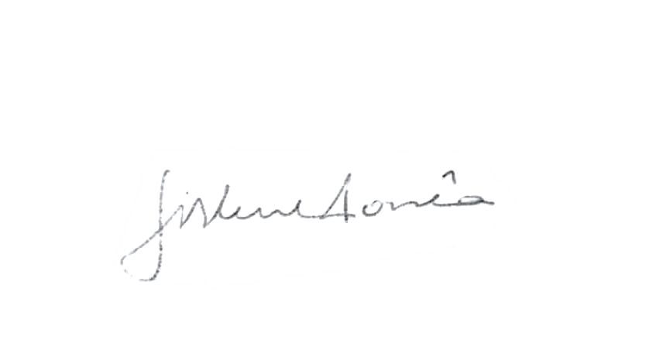
ORCID: https://orcid.org/0000-0002-8316-5315
Signature: ______________________

Name: Lucas Pradebon Brondani
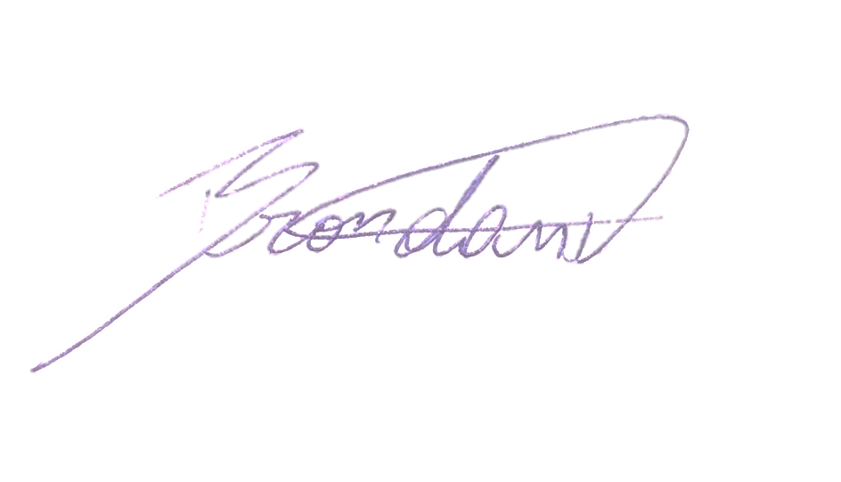
ORCID: https://orcid.org/0000-0002-7634-8527
Signature: ____________________

Name: Rafael Sarkis-Onofre
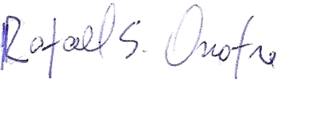
ORCID: https://orcid.org/0000-0002-1514-7879
Signature: ____________________

Name: César Dalmolin Bergoli
ORCID:
Signature: ____________________

