January 8th,2020

Dear Prof. Gonçalves,
We would appreciate if you could please consider our attached manuscript entitled “Repair Protocol of Porcelain Laminate Veneers Through Reattachment of the Fractured Ceramic Piece: A Technical Report” for possible publication in the Brazilian Dental Science.
We sent this technical report four months ago. BDS sent me an email about revision and they asked me to make corrections within 30 days. But we were late, so technical report was declined. We have resubmitted this technical report with rebuttal letter for last revision.

Looking forward to hearing from you soon.

Kind Regards

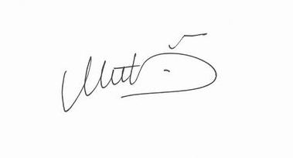

Mutlu Özcan

*Corresponding author:

Assistant Prof. Halenur Bilir
Department of Prosthodontics
Faculty of Dentistry
Istanbul Medeniyet University
Fatih Mahallesi 34956 Tuzla/İstanbul Turkey
Tel: +90 5323237520
E-mail address: halenurbilir@gmail.com (H. Bilir)

